*Florida International University*

*School of Computing and Information Sciences*

Software Engineering Focus

Feature Document

User Story ID <NVOS-29 View Search History>

**Name:** Bryan Bastida

**Team Member(s):** Andrew Castillo

**Project:** Envo Scholar

**Product Owner(s)**: Mark Finlayson

**Mentor(s)**: Masoud Sadjadi

**Instructor**: Masoud Sadjadi

**User Story Name:**

* Description: As a user, I want view my search history, so that I can get to previous results faster.

Acceptance Criteria

* User is logged in
* User has made at least 1 search
* User logs into their profile
* User clicks on the Search History button

**Use Case**

* Name: View Search History
* Actor: User, Website, MongoDB, User server
* Preconditions: User is logged in

User has made at least 1 search

* Description <Flow of events>: User logs into their account

User types a search

User goes to their profile

User clicks on the Search History button

Search History page opens and displays the users search

history

**Use Case Diagram**

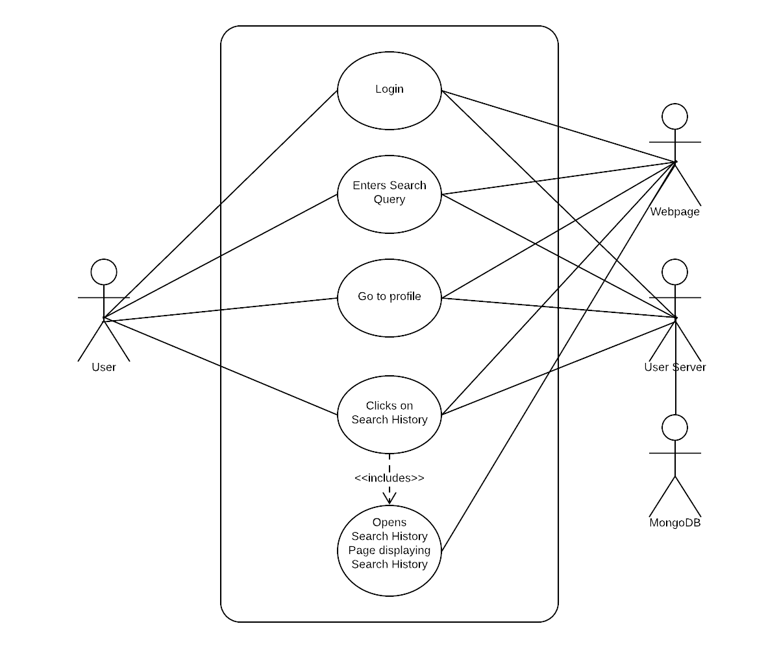

**Sequence Diagram**

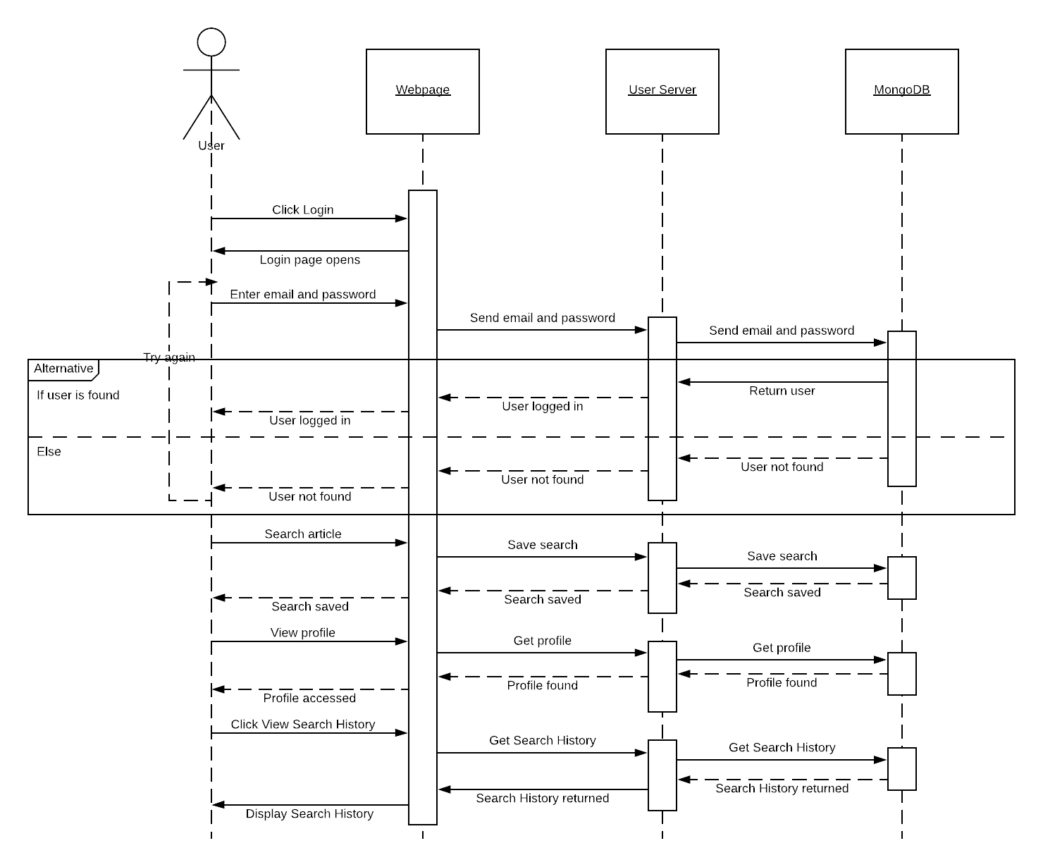

**Class Diagram**

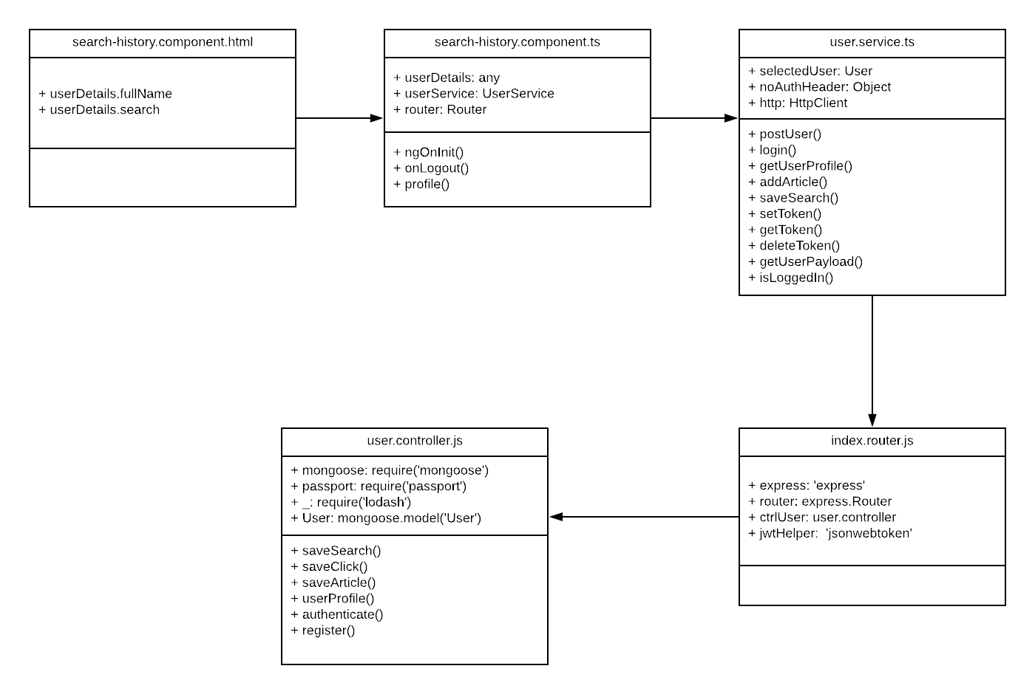

**Unit Test**

* Test case ID: NVOS-29-View-Search-History
* Description/Summary of Test: This test was made to check that a user is able to view their search history
* Pre-condition: User is logged into their account

User has made at least 1 search

User goes to their profile page

User clicks on Search History

* Expected Results: Search history is displayed
* Actual Result: Search history is displayed
* Status (Fail/Pass): Pass

**Visual User Guide**

